
A 12
Set No : 1
Sreenidhi Institute of Science & Technology
(An Autonomous Institution)
Code No: 121MA03
B. TECH. I – Year II – Semester Examinations, July, 2013 (Regular)
ENGINEERING MATHEMATICS - II ( EEE, ECE & IT )

Time: 3 Hours Max. Marks : 70

Note : No additional answer sheets will be provided.

Part-A (Objective Type)
Max.Marks:20

Answer all QUESTIONS.

1. The differential equation satisfied by y=mx after eliminating m is ________.

2. 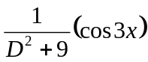=_______.

3. The inverse Laplace transform of 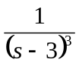is__________.

4. State Newton’s laws of cooling.

5. The partial differential equation satisfied by z=f(x²-y²) is _______.

6. The z- transform of sinnθ ______.

7. The inverse Laplace transform of 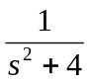is_______.

8. The Fourier sine transform of f(x) is defined as ________.

9. If f(x) = |sin x| in (-π,π), then a₀=________.

10. The Fourer series 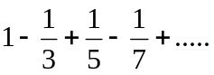 converges to ______.

Part – B
Max. Marks: 50

ANSWER ANY FIVE QUESTIONS. EACH QUESTION CARRIES 10 MARKS.

1. a) Find the orthogonal trajectory of the family of curves ay²=x³, where a is a
parameter. [ 5 ]

b) Solve (xy³+y) dx+2(x²y²+x+y⁴) dy = 0. [ 5 ]

2. Solve (by variation of parameters) 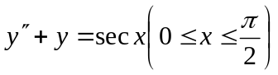.
3. a) If the air is maintained at 30⁰ C and the temperature of the body cools from 80⁰ to 60⁰C in 12 minutes, find the temperature of the body after 24 minutes. [ 5 ]

b) Solve (D²+4D+3)y=e^{-x} sinx+x. [ 5 ]

4. a) Solve x(y-z)p+y(z-x)q=z(x-y). [ 5 ]

- Use separation of variables to solve [ 5 ]
3 u_{x}+2 u_{y}=0, given u(x,0) = 4e^{-x}

5. Find the Laplace transform of the 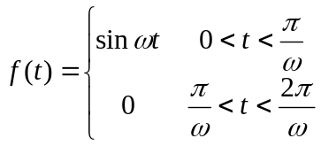 with period T=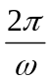.
6. a) Find the inverse z-transform of 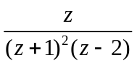. [ 5 ]
b) Solve 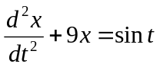 using Laplace transforms given that x(0)=1; x¹(0)=0.
[ 5 ]
7. a) Find Fourier transform of f(x)=1-x² 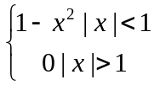. [ 5 ]
b) Find Fourier sine transform of f(x)=e^{-x}. [ 5 ]
8. Find Fourier series of f(x)=|x| and hence show that 1+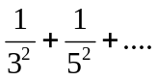=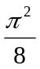.
-- 00 -- 00 --

